Copyright for test papers and marking guides remains with West Australian Test Papers.
Test papers may only be reproduced within the purchasing school according to the advertised Conditions of Sale.
Test papers should be withdrawn after use and stored securely in the school until 29th November 2019.


SEMESTER TWO

MATHEMATICS
METHODS
UNITS 1 & 2

2019

SOLUTIONS

Calculator−free Solutions

1. (a) 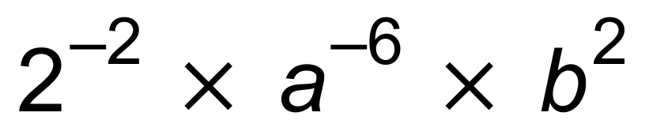
= 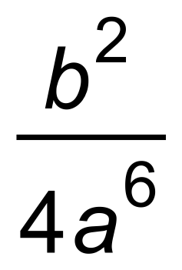
(b) 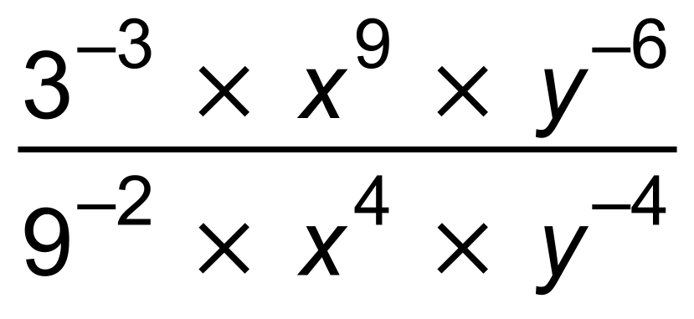
= 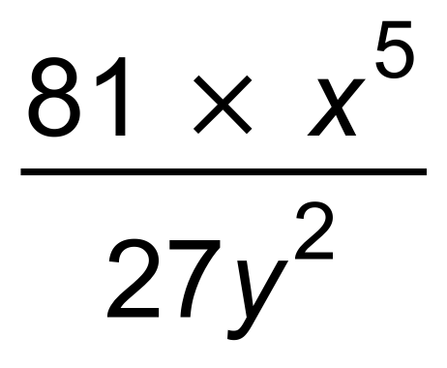
= 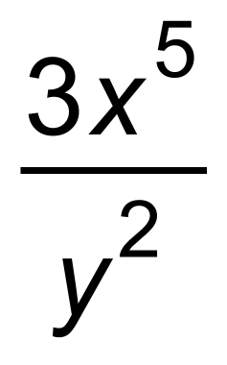 [5]

2. (a) 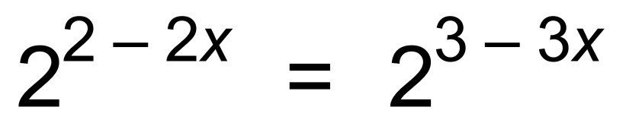
∴
(b) 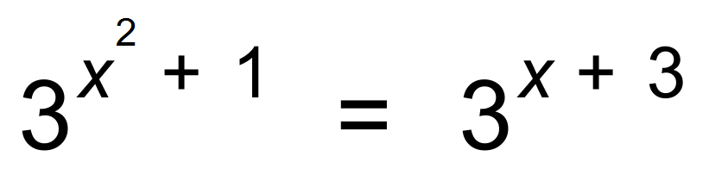
∴ 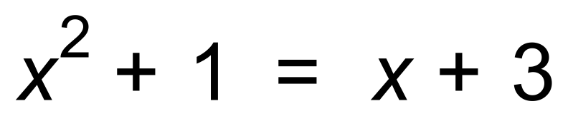
∴
∴ 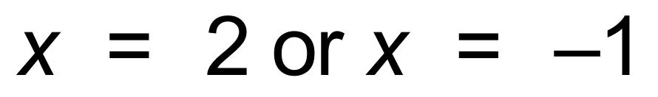 [6]

3. (a) (i) m = 4
(ii) 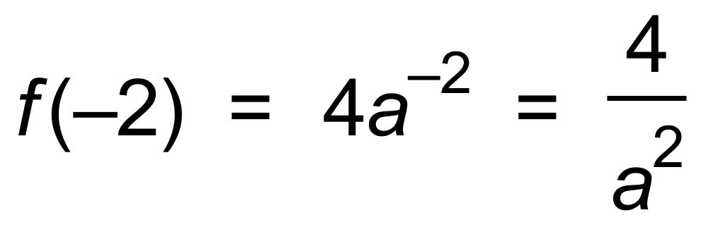
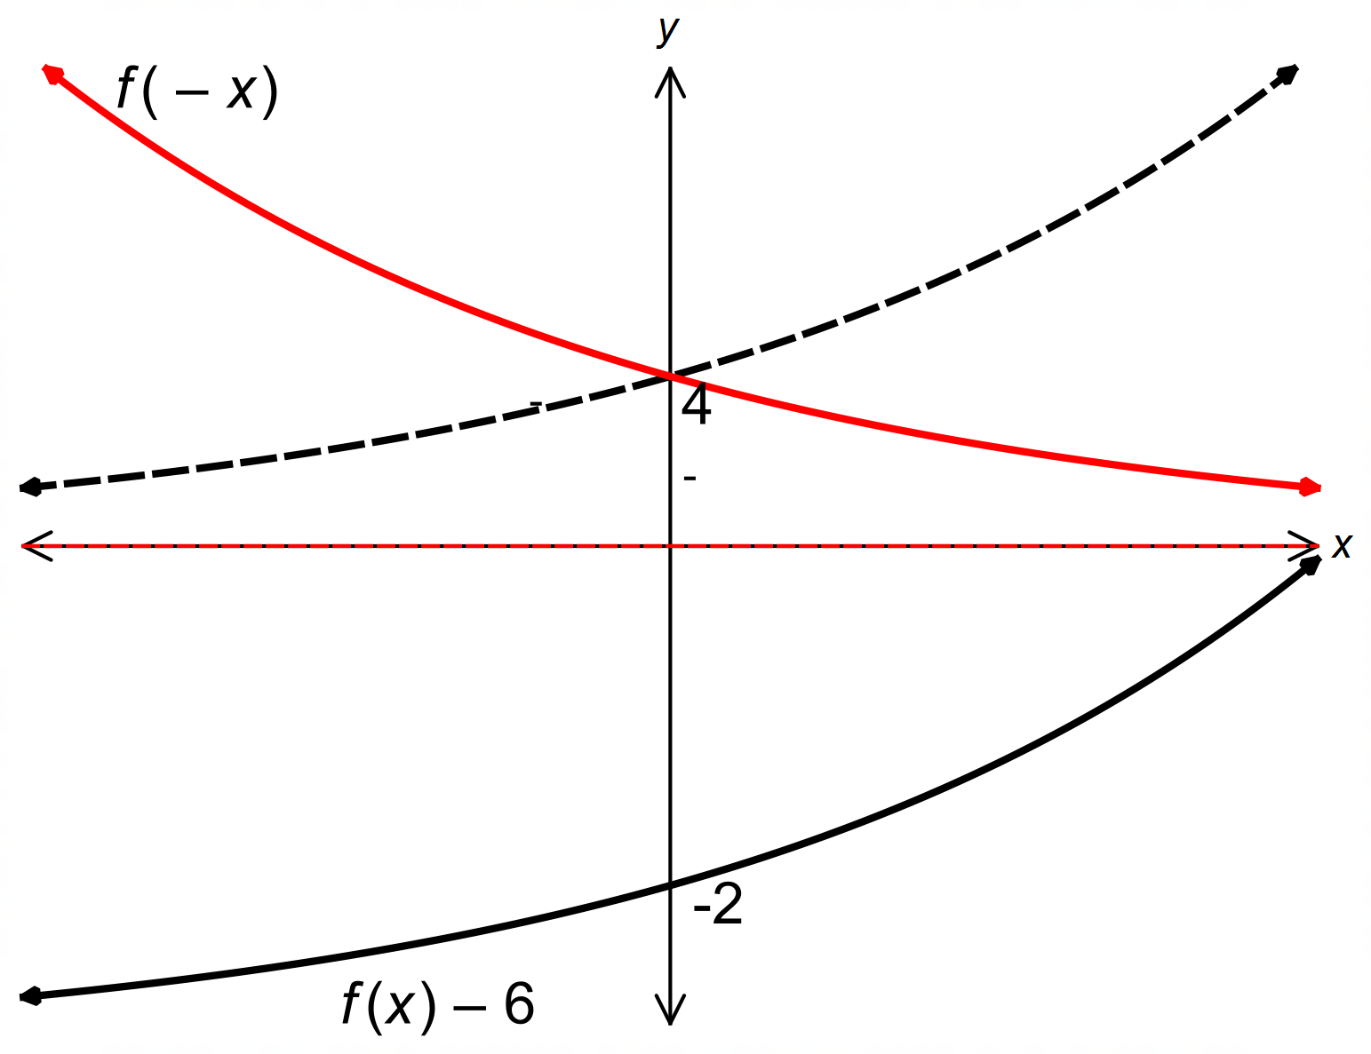 (b)

[6]

4. (a) (i) 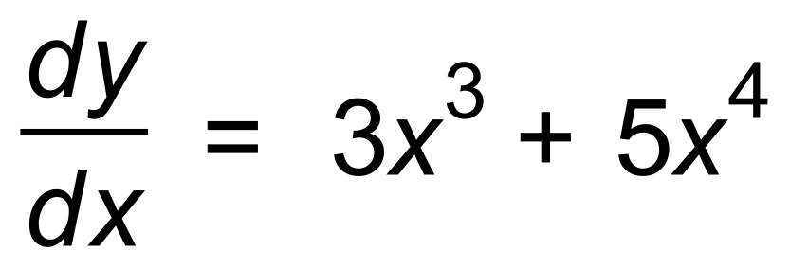
(ii) 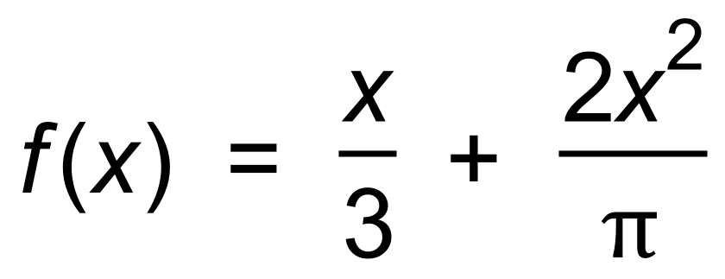
∴ 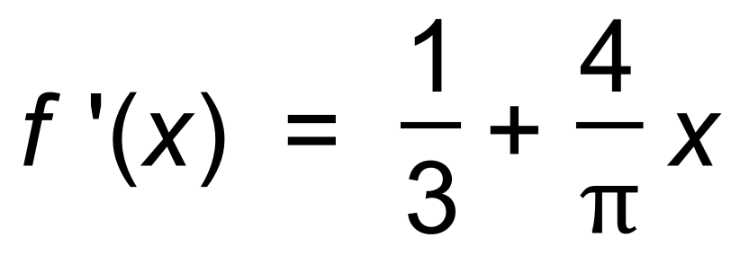
(b) −3x² [5]

5. (a) (i) 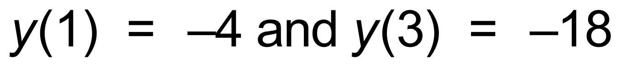
∴ 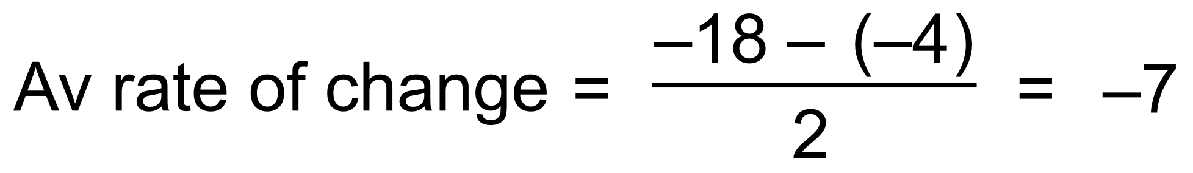
(ii) 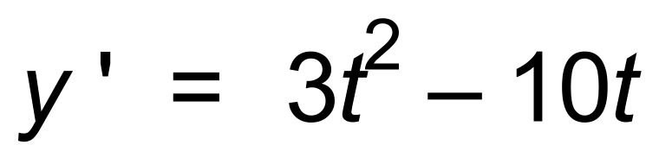
∴ 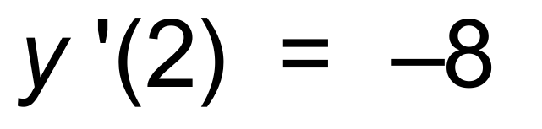
(b) 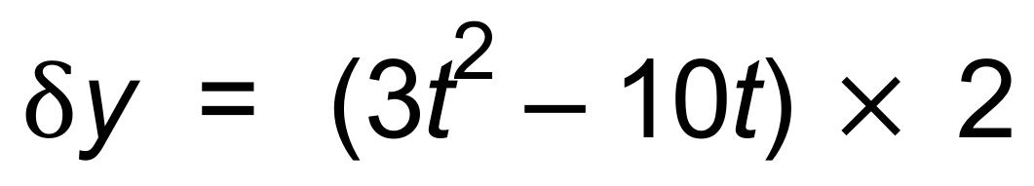
∴ 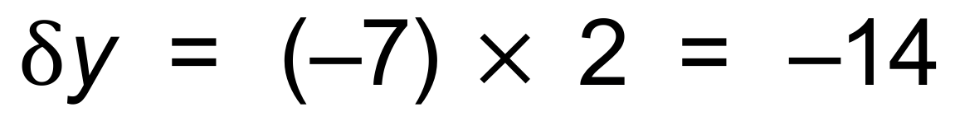
(c) 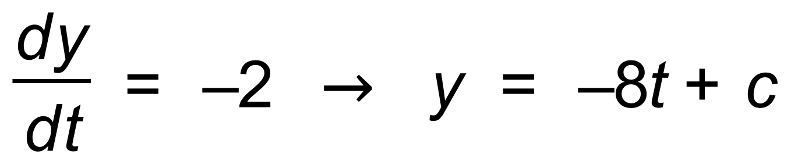
∴
∴ 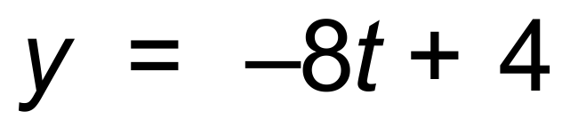 [9]

6. (a) (i) t = 1.5
(ii) t = 0.5
(b) 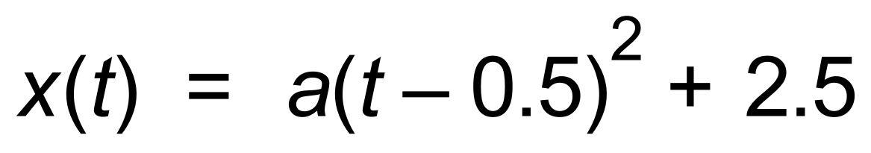
∴ 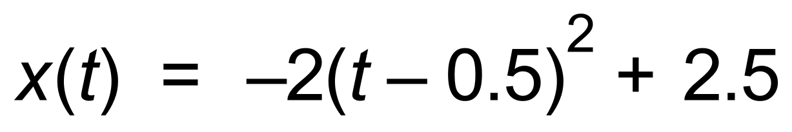 [4]

7. (a) 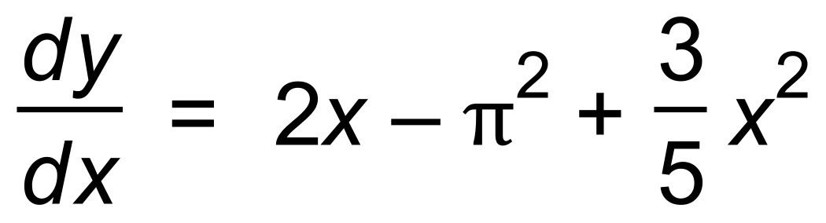
∴ 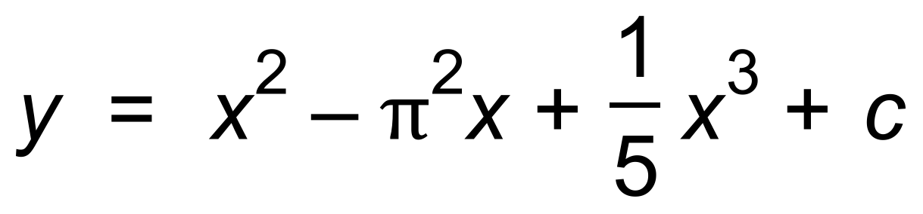
(b) 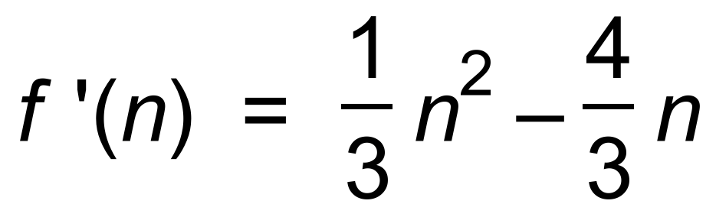
∴ 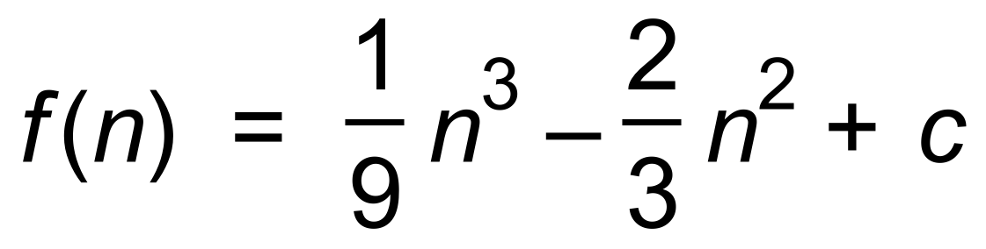 [5]

8. (a)
(b)
(c) 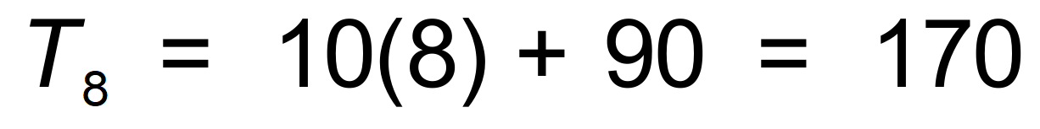 km
(d) 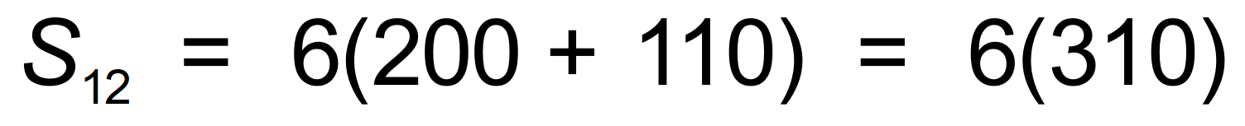
∴ = 1860 km [6]

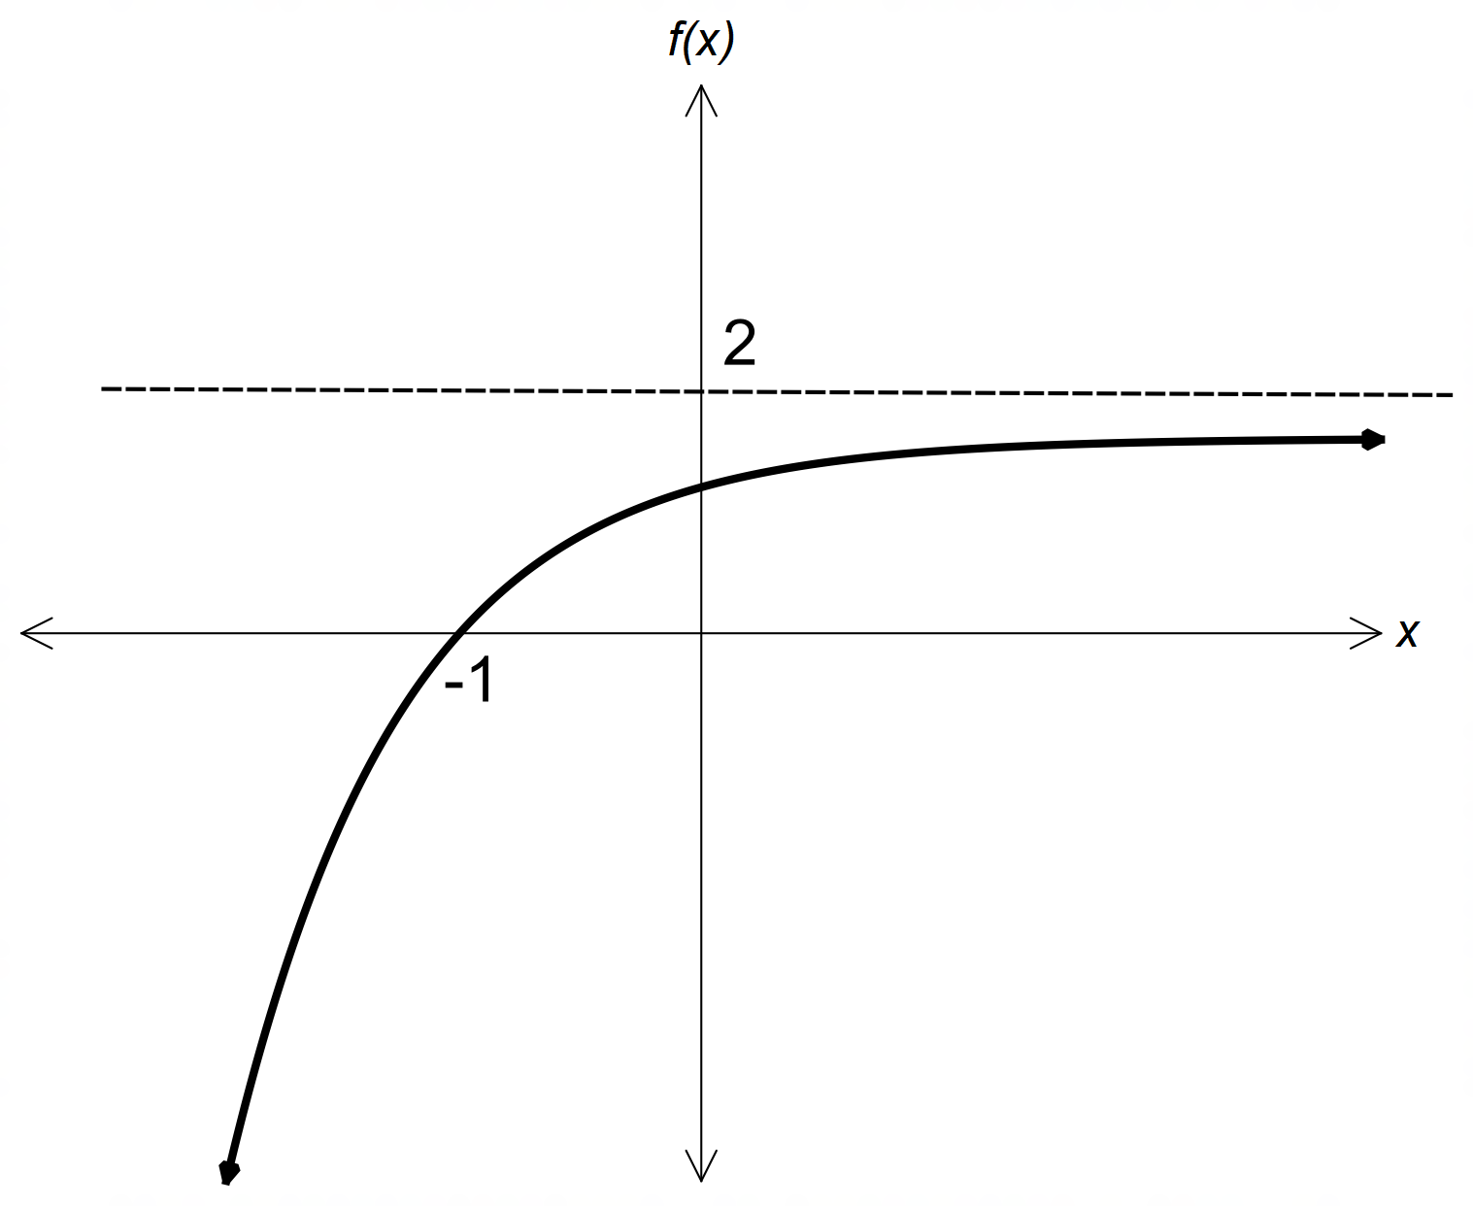9. (a)

(b)
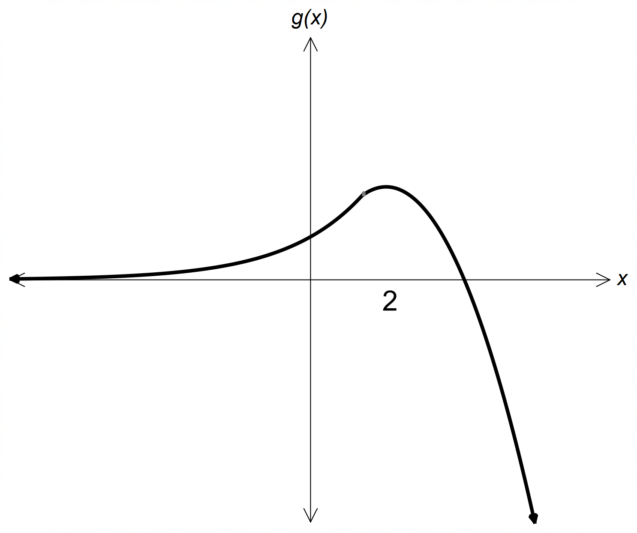

[6]

Calculator−Assumed Solutions

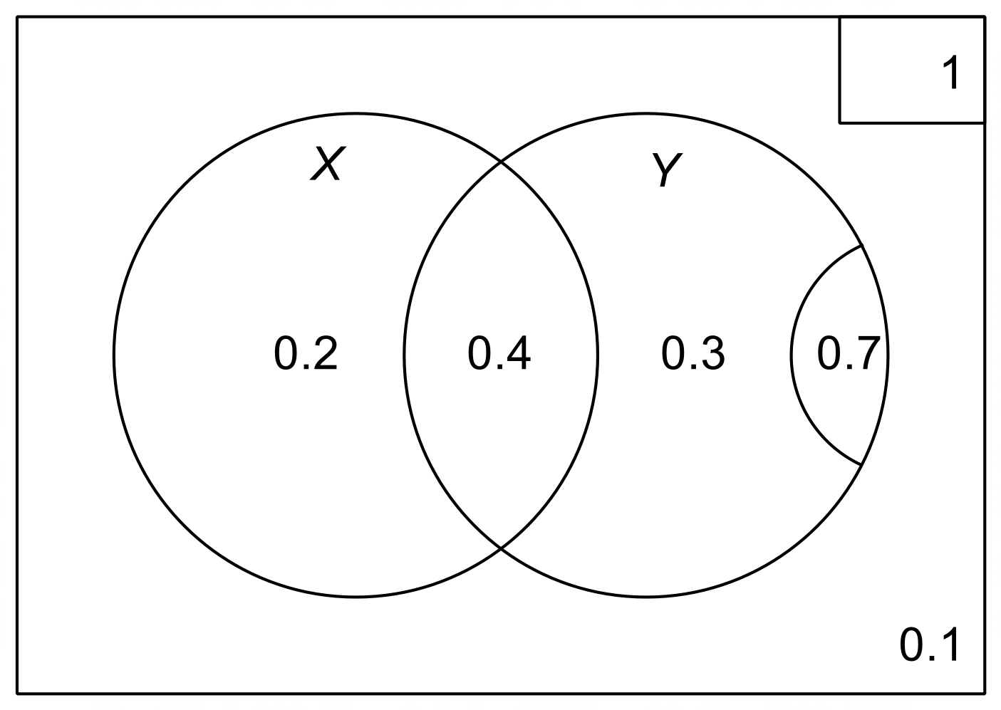10. (a)

(b) (i) 0.6
(ii) 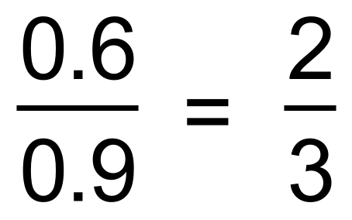
(c) 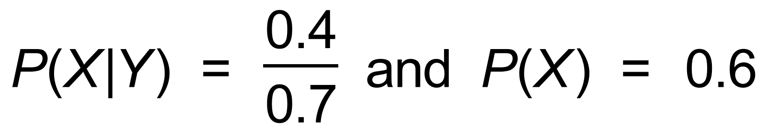
∴ not independent since 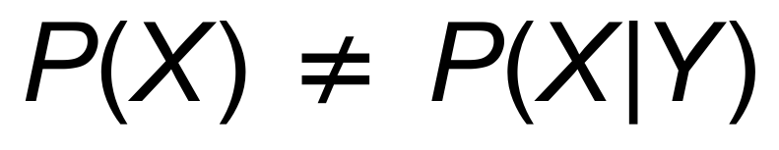
or 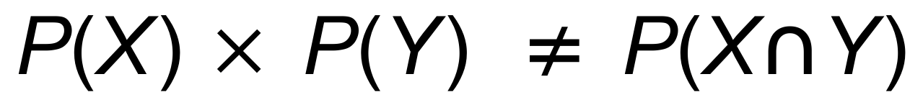 [7]

11. (a) | r | < 1
(b) 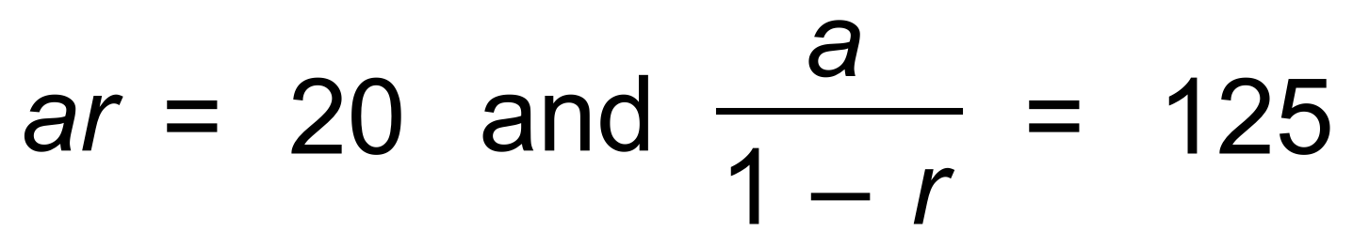
∴
(c) 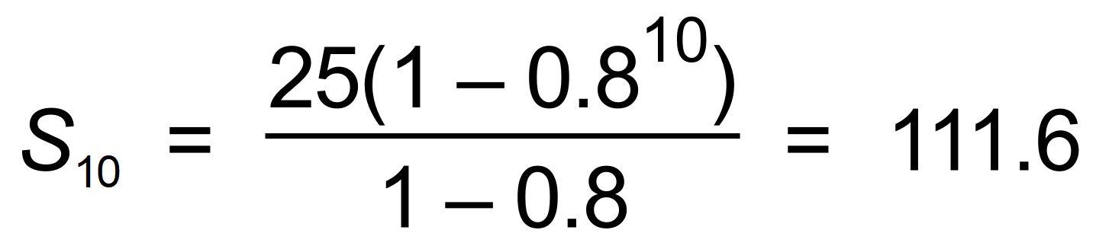
or 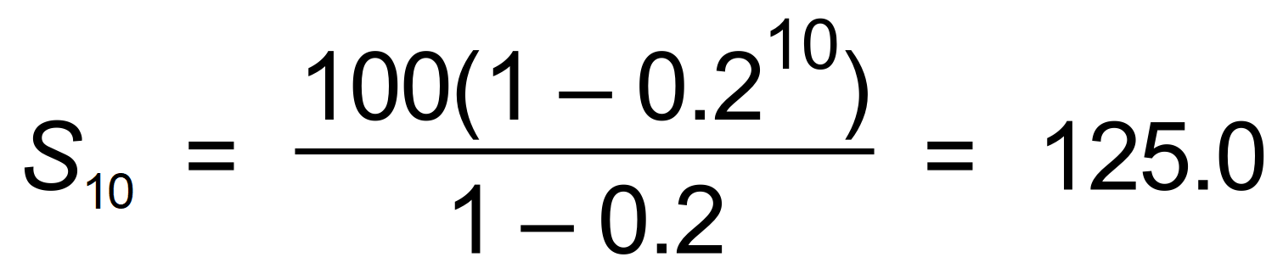 [6]

12. (a) (i) (c, 0) , (g, 0) , (k, 0)
(ii) (e, f) , (i, j)
(iii) (a, b)
(b) a ≤ x < e , g < x < i , k < x ≤ m
(c) e < x < g , i < x < k
(d) k = 2 [10]

13. (a) 0.98 means reducing by 2%
(b) 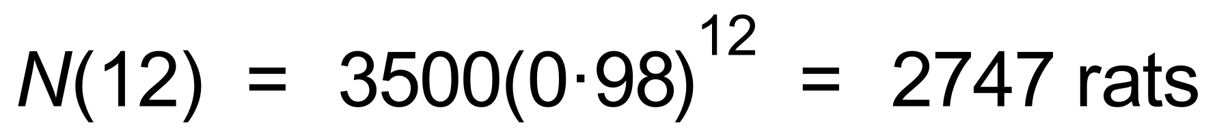
(c) 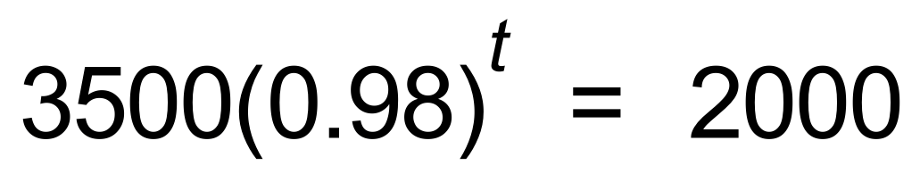
∴ t = 27.7 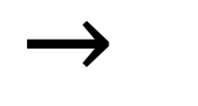 April 2021
(d) 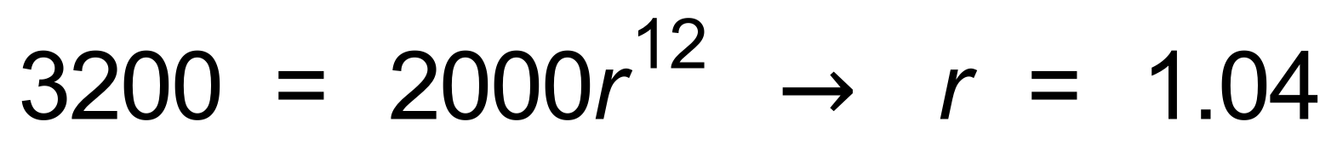
∴ 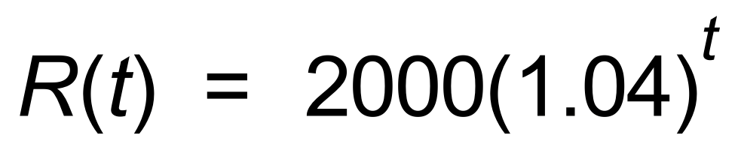
(e) 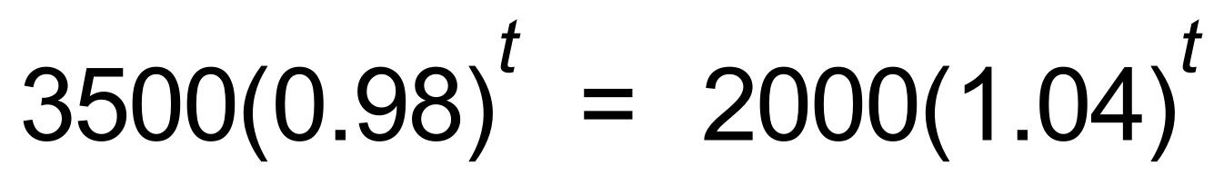
∴ t = 9.4
∴ October 2019 [10]

14. (a) 10L
(b) 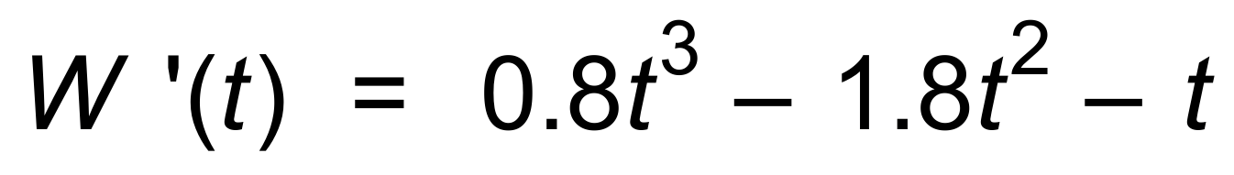
∴
∴ During the third minute.
(c) (i) W(2.7) = 5.2 L
(ii) W(4) = 14.8 L [6]

15. (a) (i) 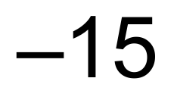m
(ii) 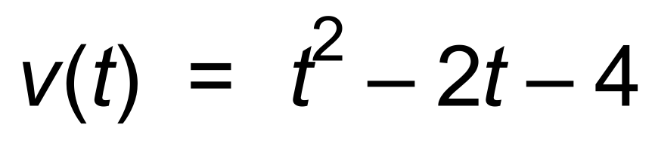
(b) 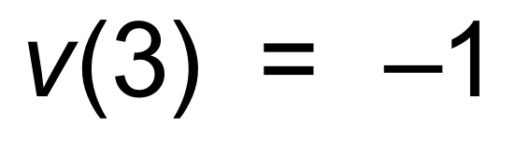
∴ Speed = 1 m/s
(c) At rest when v(t) = 0
∴ 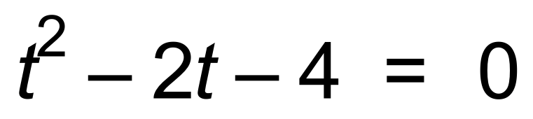
∴ t = 3.2 s
(d) x(0) = −3
x(3.2) = −15.12
x(5) = −6.33
∴ Distance travelled = 12.12 + 8.79 = 20.91 m [10]

16. (a) c = 5
(b)
∴ 4a − 2b = 0
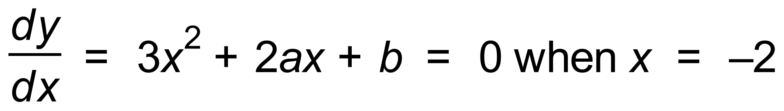
∴ 4a − b = 12
∴ a = 6 and b = 12
(c) 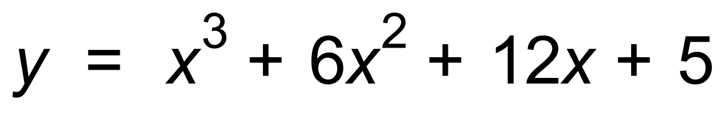
∴ [7]

17. (a) 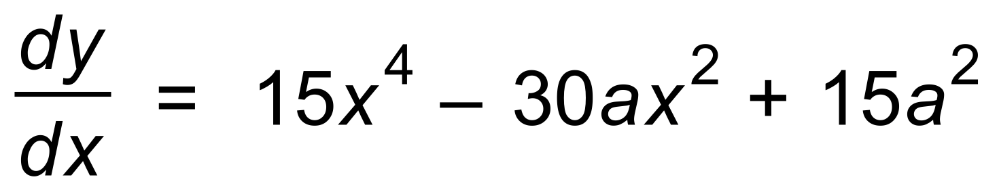
∴ 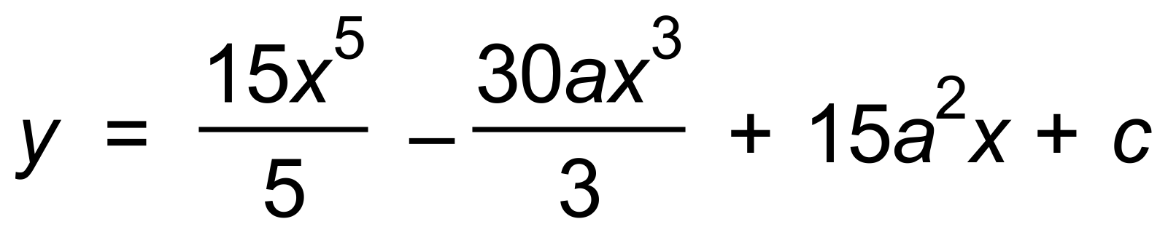
∴ (0, 0) 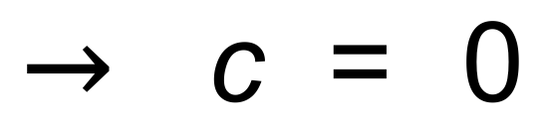
∴ 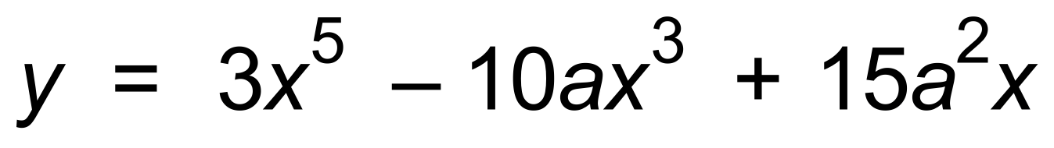
(b) 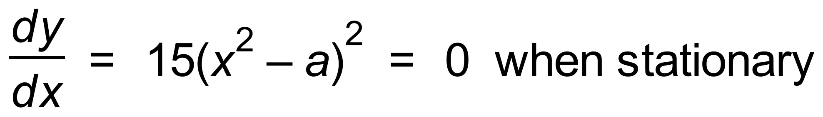
∴ 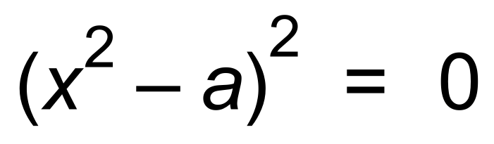
∴ 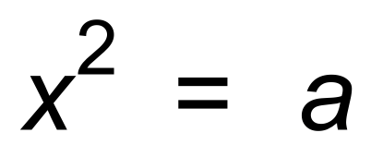
Since two stationary points a > 0 [6]

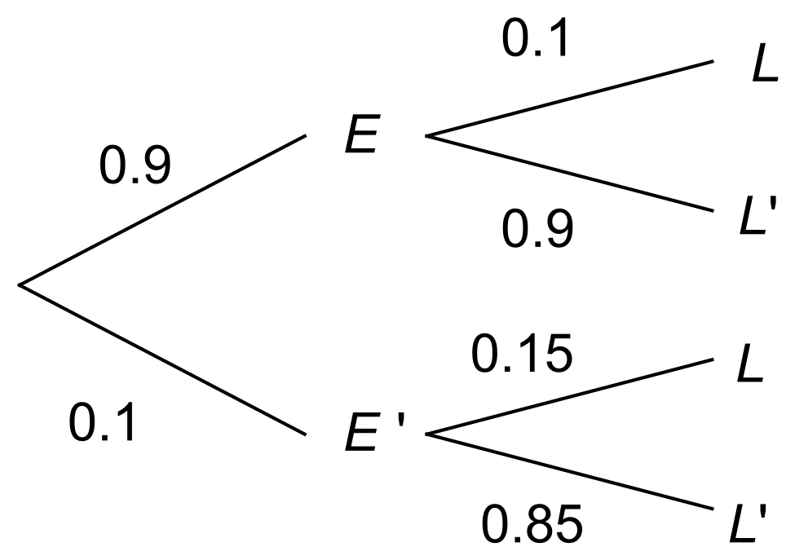18. (a)

(b) (i) P(L) = 0.9 x 0.1 + 0.1 x 0.15 = 0.105
(ii) 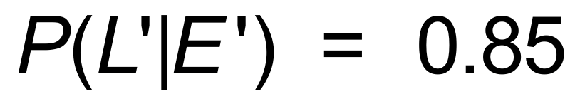
(iii) 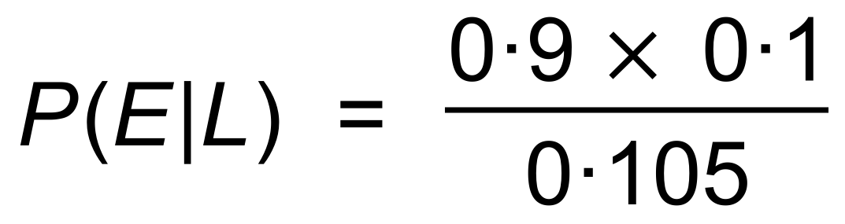
= 0.857 [7]

19. a = 0.5
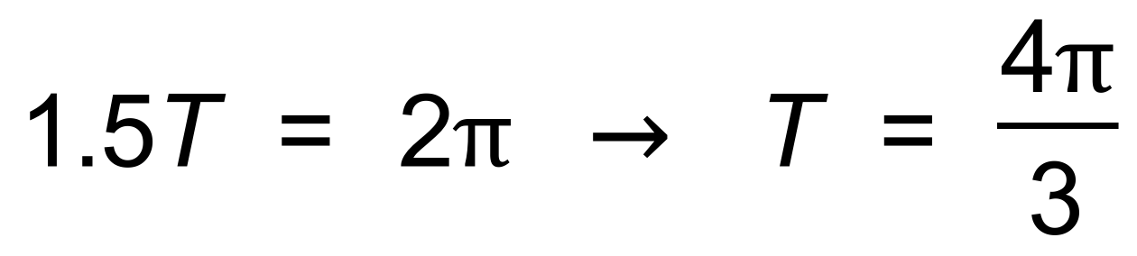
∴ 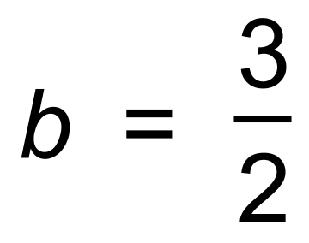
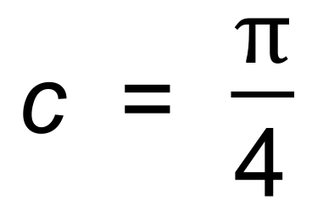
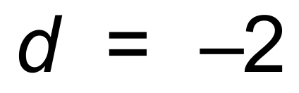
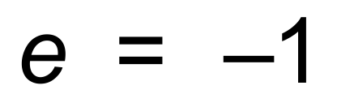 [6]

20. (a) (i) 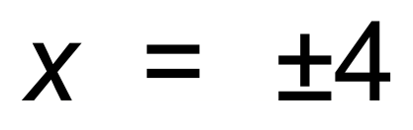
(ii) 2
(b)

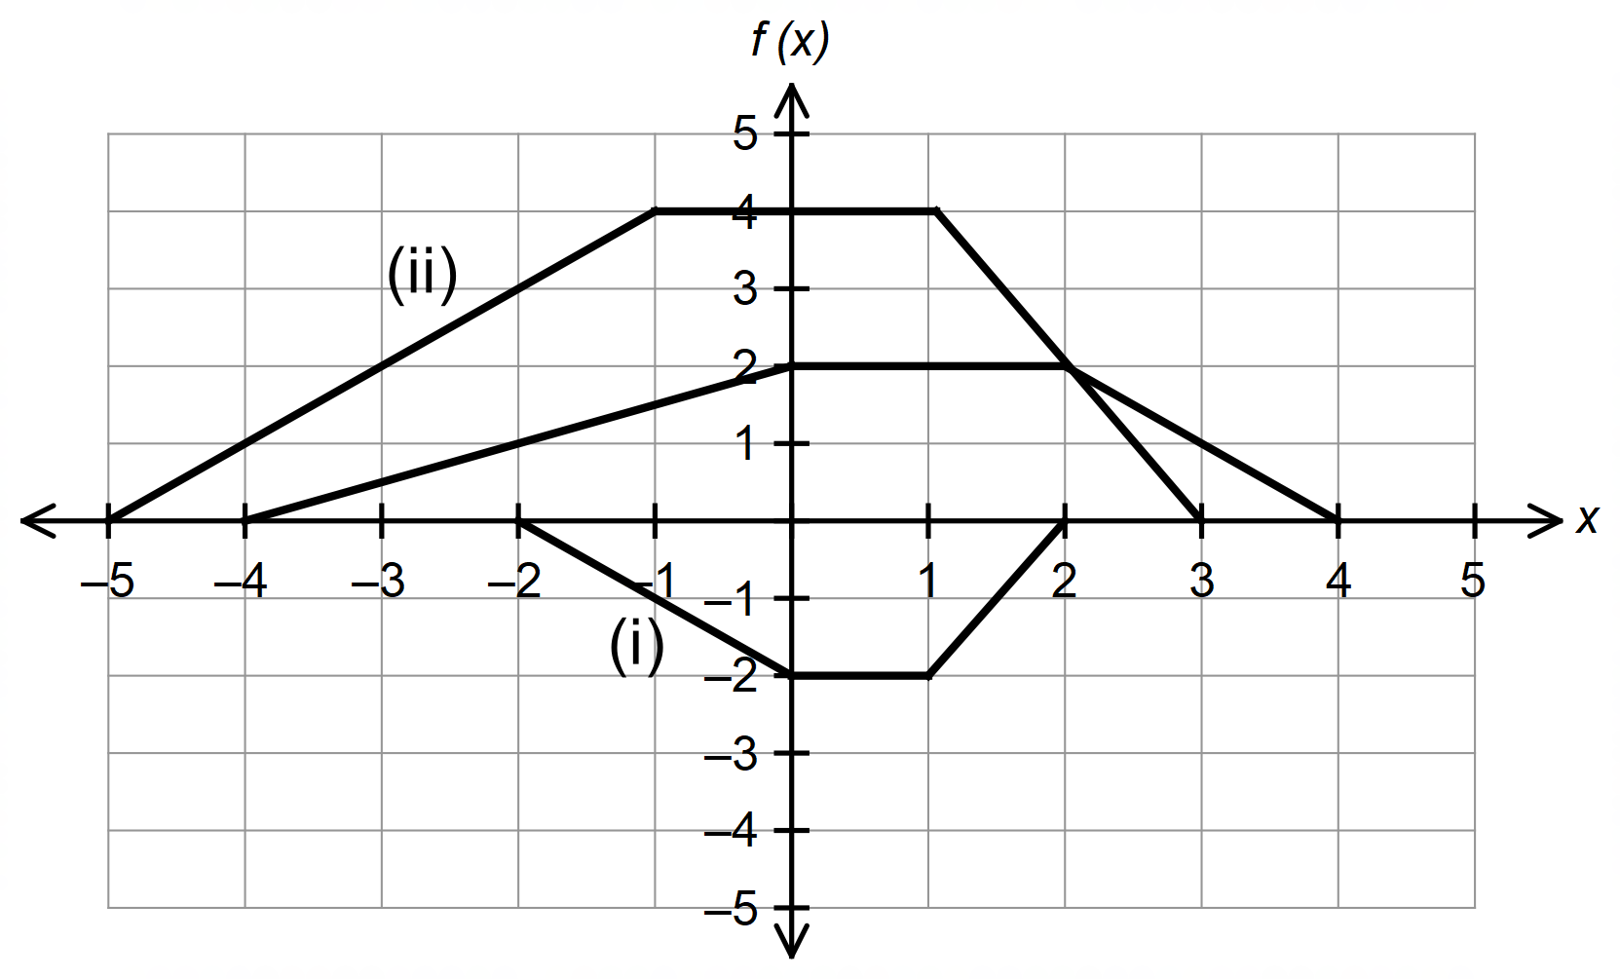

[6]

21. (a) 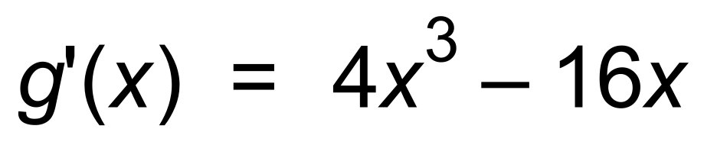
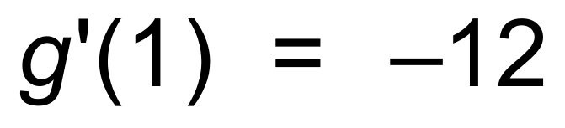
∴ y = −12x + c
(1, 9)
∴ y = −12x + 21
(b) (1.45, 3.61) and (−3.45, 62.4) [6]

22. (a) 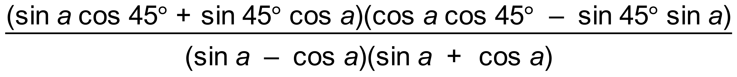
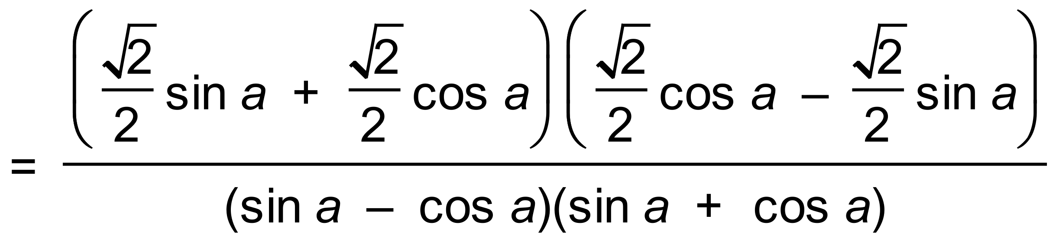
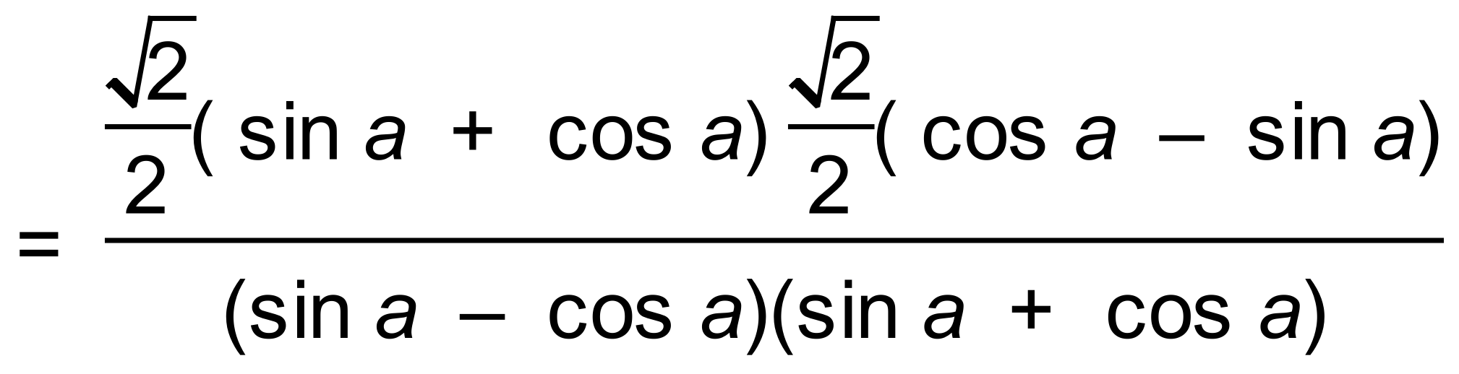
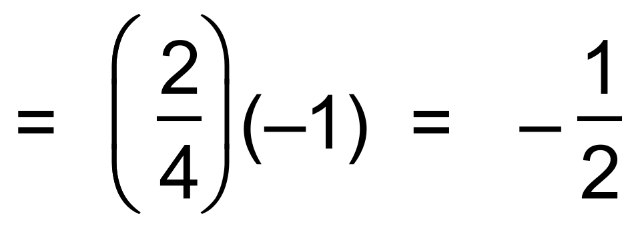
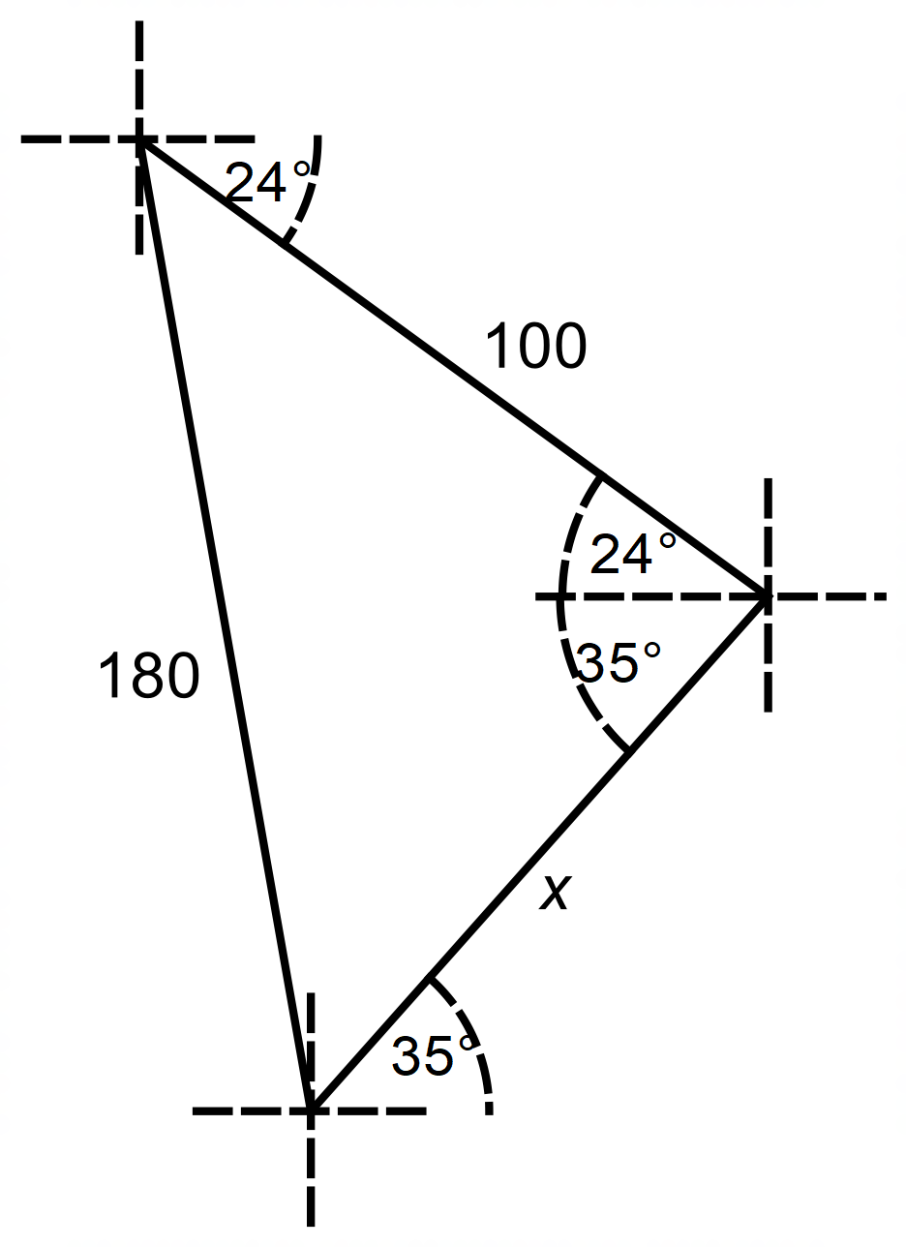 (b)

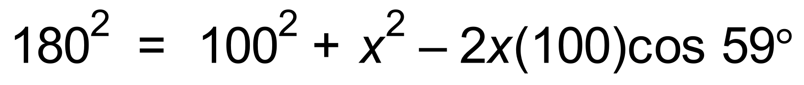
∴ 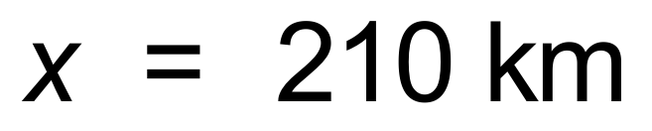 [8]

23. 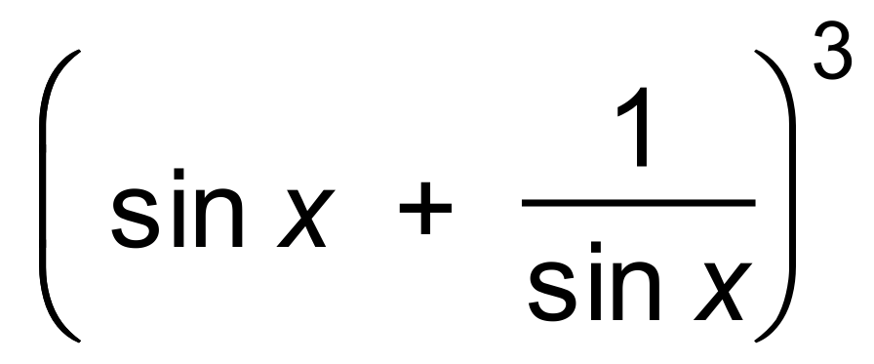
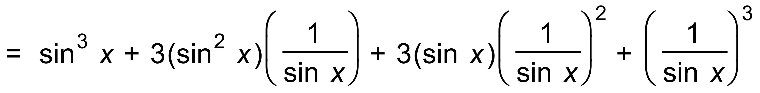

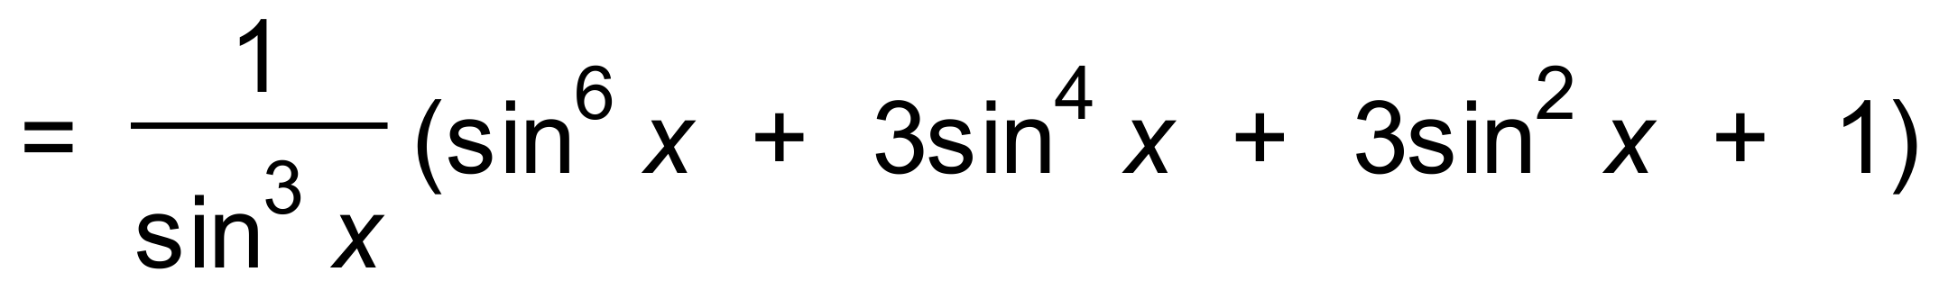 [3]

